 |  | POINT OF CARE TESTING FLOWCHART | 
1. | Start-up machine – Turn on the GeneXpert Machine first and the laptop second. |  | 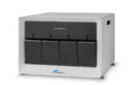
2. | Log on - “Cepheid Admin”, password “cphd” and wait for GeneXpert program to open. |  | 
3. | Backup previous test results as prompted by software. |  | 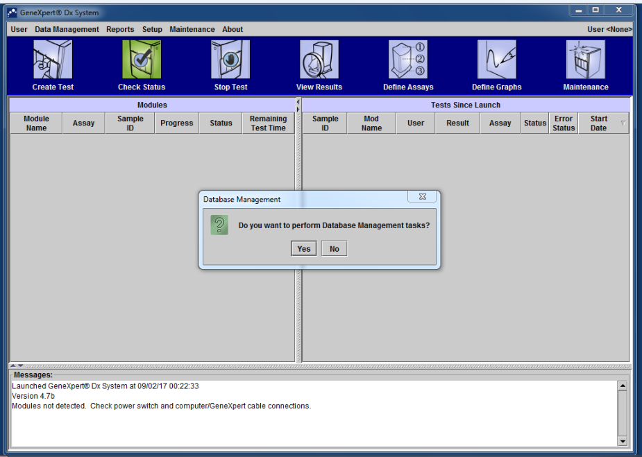
4. | Check cartridge for damage, after opening lid as well (trace of crystals). |  | 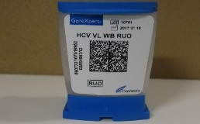
5. | Perform finger prick and collect blood. |  | 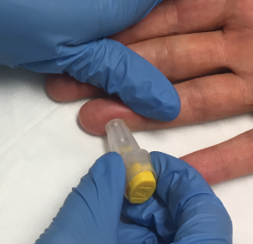
6. | Place minivette into the sample chamber and depress plunger to the end to ensure the entire sample is dispensed into the bottom of the cartridge and close cartridge lid. |  | 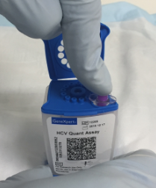
7. | Dispose of the minivette into the biohazard waste. |  | 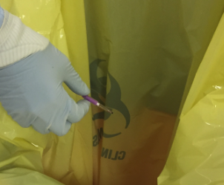
8. | Create Test on the GeneXpert software. |  | 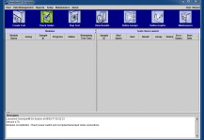
9. | Select Scan Cartridge Barcode. Use the scanner to scan the barcode until you hear a beep.  Enter the Sample ID, Serial number, assays and sample type (as below:)  - Sample ID: Screening ID (444-XXX) OR Study Subject ID (1510 – 5 Digit Site Number – 2 Digit Patient Number).  - Notes: Study visit.  Select Start Test. |  | 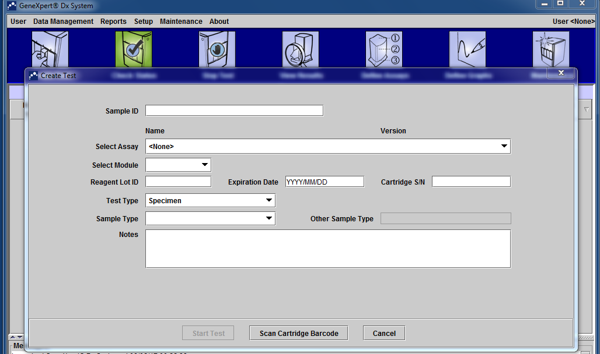
10. | Load cartridge in to the module door with BLINKING GREEN light and push door close until locked and assay starts. |  | 
11. | Once test is complete dispose of the cartridge into a biohazard waster bag. |  | 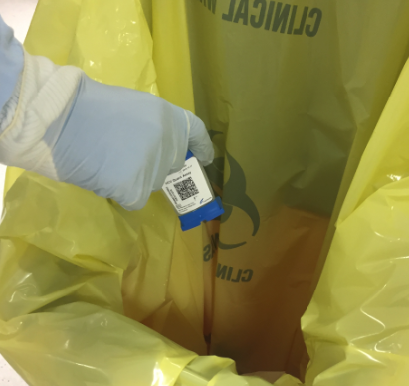
12. | Report results by clicking on View Results button and the result will be displayed in the ‘test results’ tab. |  | 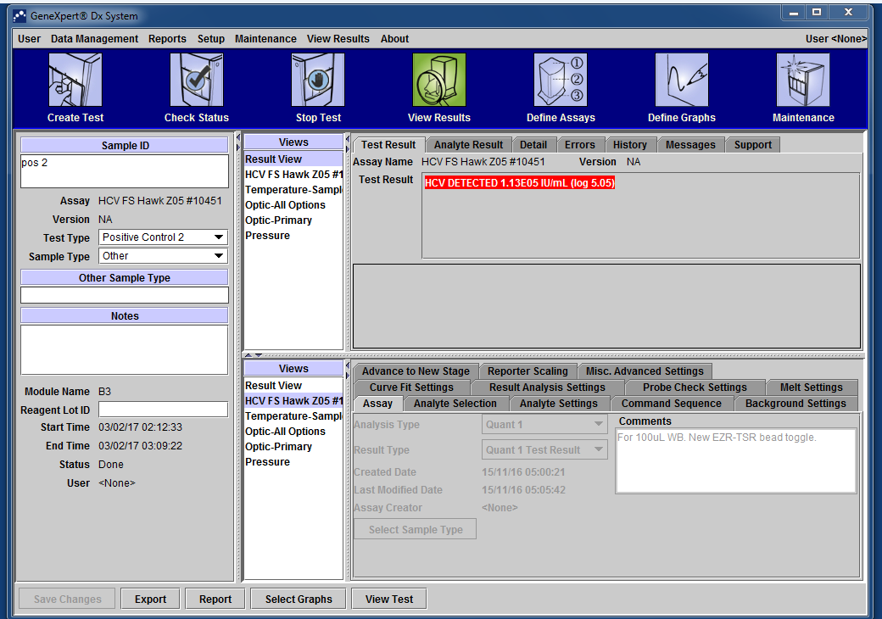
13. | Perform daily and if necessary monthly or quarterly maintenance and archive results. |  | 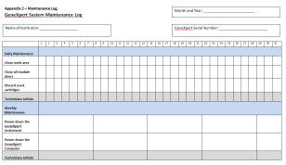
14. | Turn off the laptop first and the GeneXpert machine second. |  | 

Please follow these steps to create a test by manual data entry
(if your cartridge does not have a barcode or if the barcode scanner is not working)
8. | Create Test on the GeneXpert software.
9. | Enter the Sample ID, Serial number, assays and sample type (as below:)  - Sample ID: Study Subject ID (1605 – 5 Digit Site Number – 2 Digit Patient Number).  - Assay: HCV Finger Stick.  - Test Type: Select ‘Specimen’.  - Notes: Study visit.  - Cartridge S/N: Enter the serial number last.  NOTE: Please do not enter the past expiry date into the expiry date.

